Last Name: Miri First Name: Arman Student ID: 07700006039

1. [10pts] Find all users whose email is ‘simon.goodwin@uci.com’.

a) [6pts] Relational Algebra

b) [1pt] Parse Tree

c) [3pts] Result (1 Row)

2. [10pts] List the phones of Supporters who have the role of ‘nurse’.

a) [6pts] Relational Algebra



b) [1pt] Parse Tree

c) [3pts] Result (2 Rows)

3. [10pts] List the name, street, and city of PHLoggers who reside in the state of ‘NC’ and are associated with an Observer.

a) [6pts] Relational Algebra

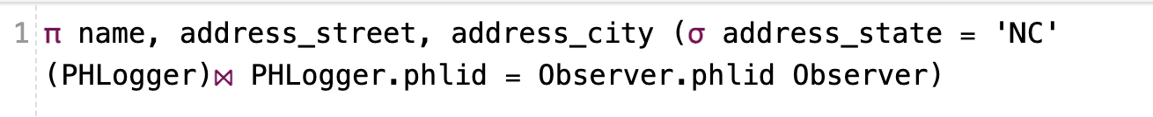

b) [1pt] Parse Tree

c) [3pts] Result (2 Rows)

4. [15pts] List the names of PHLoggers who have a thought about an interest group with topic ‘exercise’.

a) [9pts] Relational Algebra



b) [3pt] Parse Tree

c) [3pts] Result (5 Rows)

5. [15pts] Find the phlids of PHLoggers who own an Observer of kind ‘smartphone’ and are associated with an event that doesn’t have an end date.

a) [9pts] Relational Algebra



b) [3pt] Parse Tree

c) [3pts] Result (3 Rows)

6. [20pts] List the emails of users who are associated with an Observable of kind ‘bloodpressure’ as well as an Observable of kind ‘heartrate’.

a) [12pts] Relational Algebra

b) [5pt] Parse Tree

c) [3pts] Result (8 Rows)

7. [20pts] List the names and emails of PHLoggers who are members of all available interest groups with the topic of ‘alcoholism’.

a) [12pts] Relational Algebra (Hint: ***Use Division!*** )

b) [5pt] Parse Tree

c) [3pts] Result (6 Rows)

